**Veteran’s Day Script, submitted by Lisa Dullum**

**Introduction**

**Jersi 4J:** Welcome to the 2018 4th Grade Music Program, “We Remember...”

**Sam 4J:** This program is to honor those who have served or are currently serving in the military.

**Dylan 4J:** We are students from Mrs. Bartnick, Mrs. Peters, Miss Julius, and Miss Strommen’s classes.

**Macy 4J:** Our music teacher is Miss Dullum. We have been working hard to prepare for the program today.

**Taylor 4J:** We are honored to present this program as a way to say thank you to the men and women who have served or are currently serving our country.

**Song: This is My Country**



**Welcome Americans**

**Jake 4J:** Welcome, Americans. Welcome to all,

To citizens, fathers and mothers.

**Ireland 4J:** Welcome to patriots, neighbors and friends,

To children, and sisters and brothers.

**Kai 4J:** Welcome, Americans. Welcome to all.

Come share in the music we’re bringing.

**Harris 4J:** Bring your good spirits, your laugh, and your voice, And share in the songs that we’re singing.

**Landon 4J:** Hear how we sing of the land that we love. Each heart that you hear still rejoices

**Makeer 4J:** To think of our home and to give it a song,

Each heart carries on through our voices.

**Isabel 4J:** At this time, please stand for the posting of the colors and the singing of the national anthem.

**Posting of the Colors**

*Stand quietly while the colors are presented*

**Star Spangled Banner**



Oh, say can you see by the dawn's early light,   
What so proudly we hailed at the twilight's last gleaming?  
Whose broad stripes and bright stars thru the perilous fight,   
O'er the ramparts we watched were so gallantly streaming?  
And the rocket's red glare, the bombs bursting in air,   
Gave proof through the night that our flag was still there.  
Oh, say does that Star - Spangled Banner yet wave  
O’er the land of the free and the home of the brave?

***The Pledge of Allegiance***

I pledge allegiance to the Flag of the United States of America,

And to the Republic for which it stands, one Nation under God,

Indivisible, with liberty and justice for all.

**Song: ALLEGIANCE RAP**

**Dionysius 4P:** Our next song is “You’re A Grand Old Flag” We will repeat Verse 1 three times, please feel free to join us in singing after the first time through.

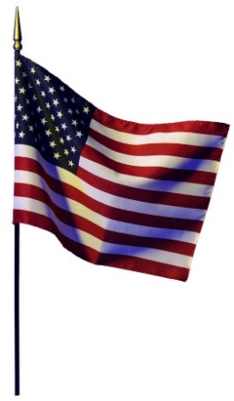

**You’re A Grand Old Flag**

You’re a grand old flag, you’re a high flying flag;

And forever in peace may you wave;

You’re the emblem of the land I love,

The home of the free and the brave.

Every heart beats true under red, white, and blue,

Where there’s never a boast or brag;

But should auld acquaintance be forgot,

Keep your eye on the grand old flag.

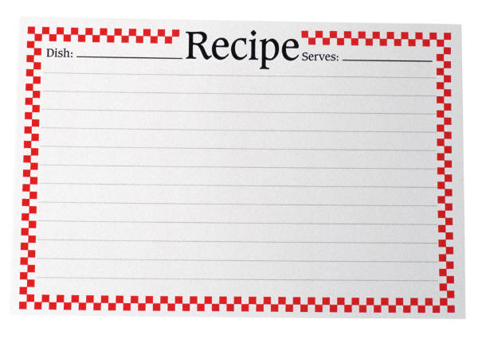**Flag Recipe**

**Brooklyn 4S:** We are going to fix for you a treat that is really grand.

**Connyr 4S:** We’ll make for you a recipe – the greatest in the land!

**Ellie 4S:** First, we will put a heaping cup of Red for courage true. (Pause)

**Landon 4S:**  Then, we will add for loyalty a dash of heavenly Blue (Pause)

**Ava 4S:** For purity, we will now sift in a layer of snowy White (Pause)

**Peyton 4S:** We will sprinkle in a pinch of stars to make it come out just right. (Pause)

**Miles 4S:** We will stir and stir and then you will see, that we have made “Old Glory.” (Pause)

**Khadijah 4S:** The most beautiful flag in all of the world, let us always be loyal to it!

**My Flag**

When I see my flag, my country’s flag, I am always touched inside.

When I see my flag, my country’s flag, I am always filled with pride.

When I see my flag, my country’s flag, I know that it’s my own.

When I see my flag, my country’s flag, I know I’m not alone.

(I know I’m not alone)

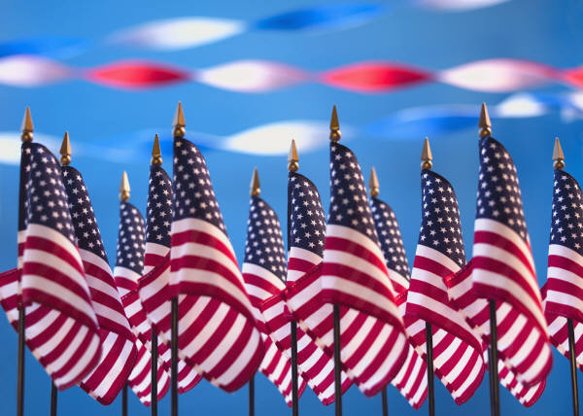

**Armed Forces Poem**

**Ryley 4B:** Let’s honor our military, The men and women who serve,

**Hudson 4B:** Whose dedication to our country, Does not falter, halt, or swerve.

**Daveen 4B:** We are grateful for all they’ve given,

Their sacrifice felt deep.

**Ella 4B:** The light of freedom shines this day

For all of us to keep.

**Ethan 4B:** If you have served or are currently serving in any branch of the military, Please stand to be recognized at this time.

**Griffin 4B:**  The United States Marine Corps. Honor, courage and commitment; these are the values that define a marine. The first on the scene, first to help and first to fight, the US Marine Corps has earned the reputation as “America’s 9-1-1 Force.”

**The Marine’s Hymn**

From the halls of Montezuma, to the shores of Tripoli;

We will fight our country’s battles in the air, on land, and sea.

First to fight for right and freedom, and to keep our honor clean,

We are proud to claim the title of United States Marine.

**Lujin 4B:** The Air National Guard provides almost half of the Air Force tactical airlift support and has responsibility for air defense of the United States.

**Cate 4B:** The Air National Guard’s mission is to maintain units available for prompt response during war and also during national emergencies.

**Ivy 4B:** The three core values of the US Air Force are integrity first, service before self and excellence in all we do.

**Avery 4B:** These values inspire the soldiers to do their very best at all times, tying them to the great warriors and public servants of the past.

**The Air Force Song**

Off we go, into the wild blue yonder

Climbing high, into the sun;

Here they come, zooming to meet our thunder,

At ‘em boys, give –er the gun.

Down we dive, spouting our flames from under,

Off with one heck of a roar.

We live in fame, or go down in flame,

Nothing‘ll stop the US Air Force.

**Bella 4B:**  The United States Coast Guard is a service within the Department of Homeland Security and is one of the nation’s 5 armed services.

**Emma 4B:**  To serve the public, the Coast Guard has 5 important roles: safety, security, mobility, defense, and protection of natural resources.

**Amanda 4B:** The three core values of the United States Navy are honor, courage, and commitment.

**Brooklyn 4B:** By living out these values, sailors build confidence, develop team skills and learn to accept responsibility for their actions.

**Anchors Aweigh**

Anchors aweigh, my boys, anchors a-weigh.

Farewell to college joys, we sail at break

of day-ay-ay-ay.

Through our last night on shore, then to the foam.

Until we meet once more here’s wishing

you a happy voyage home.

**Megan 4B:**  The Army National Guard of the United States is a [reserve military force](https://en.wikipedia.org/wiki/Military_reserve_force), composed of military members from each state and US territory.

**Tarnue 4B:**  The Army National Guard provides units available for prompt mobilizations during war and national emergencies.

**Simara 4S:**  The National Guard provides soldiers trained to protect life and property and are ready to defend the United States and its interests all over the globe.

**Chris L. 4S:** Many people know what the words loyalty, duty, respect, selfless service, honor, integrity and personal courage mean, but how often do you see someone actually living up to them?

**Delaney 4S:** Soldiers in the United States Army learn these values in detail and live them every day and in everything they do.

**Army Song**

First to fight for the right and to

build the nation’s might,

And the Army goes rolling along.

Proud of all we have done,

Fighting ‘til the battle’s won,

And the Army goes rolling along.

Then it’s Hi, Hi, hee! In the field artillery,

Count off the cadence loud and strong

For where-e’er we go, you will always know,

That the Army goes rolling along,

2ND TIME - That the Army goes rolling along

2ND TIME - That the Army goes rolling along

**Thank You Soldiers**

Before Music Starts…

**Camden 4P:** When I lay my head down every night and go to sleep in peace, I can stay there knowing all is well, while you’re standing at your feet.

**Harper 4P:** Keeping watch, protecting shore to shore, in the air and oceans, too. Defending freedom at all cost, for the red, white, and the blue.

**Aubrey 4P:** To the soldiers who have traveled on to countries far and near,

**Jolynn 4P:** In peace and war you paid the price for the cause you hold so dear.

**Ava 4P:** That we may wake each morning bright and know that freedom rings; Because of your great sacrifice, your country joins to sing.

*Music Starts….*

**Reagan 4P:** Thank you, oh thank you, men and women brave and strong

**Annabelle 4P:** To those who serve so gallantly, we sing this grateful song.

Song: **You Are Our Heroes**

**American Pride**

**Olivia 4S:** Standing together with patriot pride,

With honor we look at the past

**Ruth 4S:** And the sacrifices so many have made

To help our great country to last.

**Lily 4P:** Now we continue to follow the course

Our forefathers placed in our trust.

**Simran 4P:** Together in freedom, united we stand

Carrying on as we must.

**Naomi 4P:** The future belongs to each one of us here,

No matter how obstacles seem!

**Elijah 4P:** Pursuing the happiness we are endowed,

We share our American dream!

**Enoch 4P:** We share it all over this great land of ours,

For that’s the American way!

**Brayden 4P:** We’re in this together, we’re living it now.

For we are Americans - every day!

**Song: All-American Me and You**

**Song: This is America**

**Kannon 4P:** Thank you for coming to our music program! Following the retiring of the colors, all fourth graders will be in the commons area, so please come say hello!

***Aubrey 4P:*** *At this time, please stand for the retiring of the colors.*

**Retiring of the Colors**

*Stand quietly while the colors are retired*