Sub Information for

Using MusicplayOnline

1. Got to https://musicplayonline.com

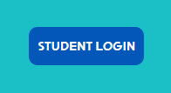
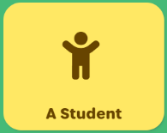

2. If it asks you to log in, log in as a STUDENT
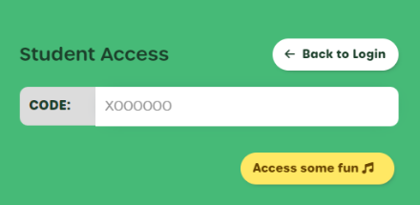

3. The student access code is .

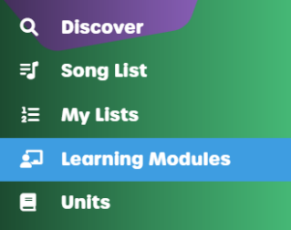

4. On the left menu, select Learning Modules.

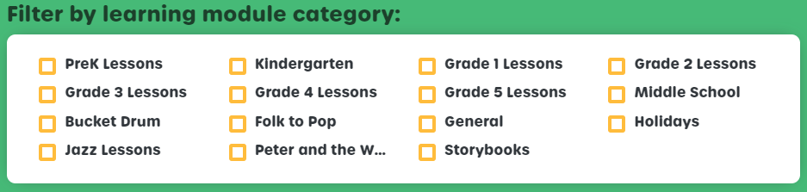

5. Choose the grade.

6. Scroll through the list until you find the week you require.
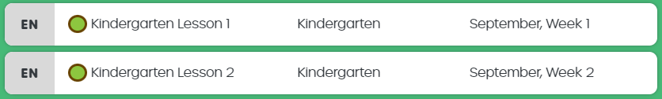

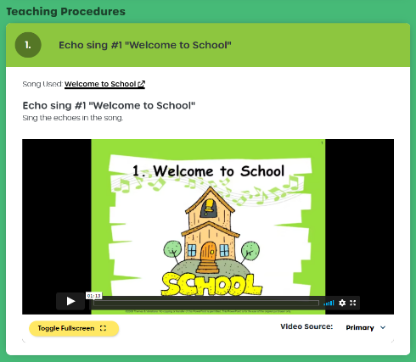

7. Open the lesson and do each activity.

Note how many activities were
completed on the notes for the
teacher page.

Sub’s Notes for the Teacher

Sub’s Name: | Date:

Class 1: | Activities Completed? #
Notes:

Class 2: | Activities Completed? #
Notes:

Class 3: | Activities Completed? #
Notes:

Class 4: | Activities Completed? #
Notes:

Class 5: | Activities Completed? #
Notes:

Class 6: | Activities Completed? #
Notes:

Class 7: | Activities Completed? #
Notes:

Additional Notes:

